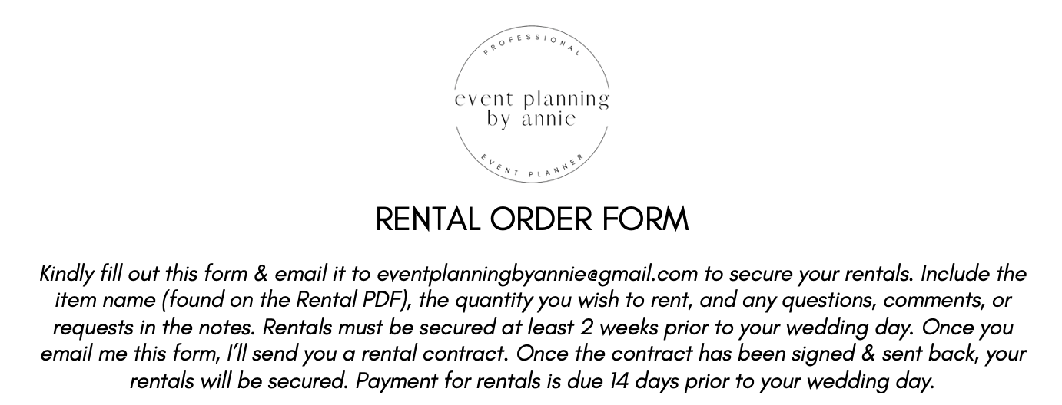

NAME:
WEDDING DATE:

ITEM | QUANTITY | NOTES (IF ANY)

